Lab 5: Configuration of Domain Name System (DNS), Web Server & Email Server

Theory
1. Domain Name System (DNS)
DNS is a naming service that translates human-readable domain names into IP addresses. It allows users to access network services using names instead of remembering numerical IP addresses.
Working of DNS:
- A client sends a request for the IP address associated with a domain name.
- The DNS server searches its configured records for the requested domain.
- The corresponding IP address is returned to the client.
- The client uses the IP address to establish communication with the required server.
2. Web Server
A web server stores and delivers web pages and other web resources to clients over a network. It commonly uses the HTTP/HTTPS protocols for communication.
Working of Web Server:
- The client enters a website address or requests a web resource.
- DNS resolves the domain name to the web server's IP address.
- The client sends an HTTP request to the server.
- The web server processes the request and sends the requested web page as an HTTP response.
- The client displays the received web content.
3. Email Server
An email server manages the sending, receiving, and storage of electronic mail between users. It uses protocols such as SMTP for sending mail and POP3/IMAP for receiving mail.
Working of Email Server:
- The sender composes an email and submits it to the outgoing mail server.
- SMTP is used to transfer the email to the recipient's mail server.
- The recipient's mail server stores the email in the recipient's mailbox.
- The recipient's email client connects to the mail server using POP3 or IMAP.
- The email is retrieved and displayed to the recipient.
4. Server Configuration
In the lab, DNS, web, and email services are configured in a network simulation environment. Appropriate IP addresses, domain names, DNS records, and email accounts are configured, and connectivity and services are tested between client devices and the respective servers.
Components Required
- Cisco Packet Tracer
- 2 Routers (2901)
- 2 Switches (2960)
- PCs/Laptops
- 1 Server
- Copper Straight-Through Cables
- Copper Cross-Over Cables

Procedure
- Network Topology Setup
Steps
- Open Cisco Packet Tracer.
- Place two routers, two switches, and end devices.
- Connect:
- PCs to switches using Copper Straight-Through cables.
- Switches to routers.
- Routers to one another.
- Assign IP addresses to every router interface.
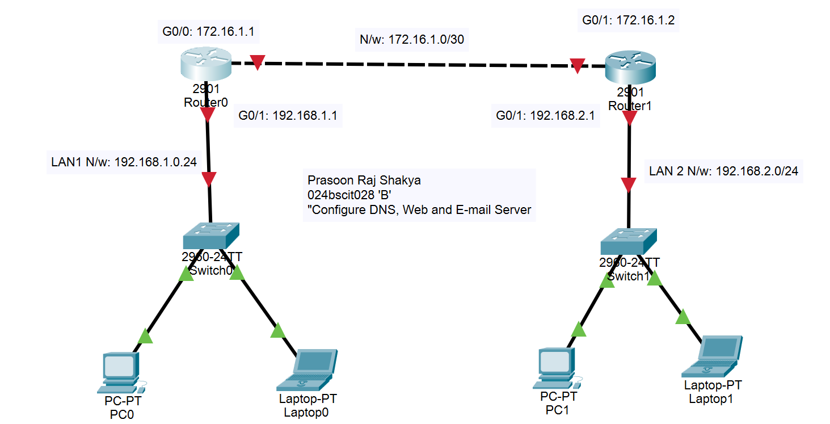
- Configure IP addresses on router interfaces.
- Configuring Router0()
Prasoon_R0(config)#interface gigabitEthernet 0/0
Prasoon_R0(config-if)#ip address 172.16.1.1 255.255.255.252
Prasoon_R0(config-if)#no shutdown
Prasoon_R0(config-if)#
%LINK-5-CHANGED: Interface GigabitEthernet0/0, changed state to up
Prasoon_R0(config-if)#exit
Prasoon_R0(config)#interface gigabitE
Prasoon_R0(config)#interface gigabitEthernet 0/1
Prasoon_R0(config-if)#ip address 192.168.1.1 255.255.255.0
Prasoon_R0(config-if)#no shutdown
Prasoon_R0(config-if)#
%LINK-5-CHANGED: Interface GigabitEthernet0/1, changed state to up
%LINEPROTO-5-UPDOWN: Line protocol on Interface GigabitEthernet0/1, changed state to up
Prasoon_R0(config-if)#exit
Prasoon_R0(config)#exit
Prasoon_R0#
%SYS-5-CONFIG_I: Configured from console by console
Prasoon_R0#wr
Building configuration...
[OK]
Prasoon_R0#

- DHCP
Prasoon_R0#conf t
Enter configuration commands, one per line. End with CNTL/Z.
Prasoon_R0(config)#ip dhcp pool LAN1
Prasoon_R0(dhcp-config)#network 192.168.1.0 255.255.255.0
Prasoon_R0(dhcp-config)#default-rou
Prasoon_R0(dhcp-config)#default-router 192.168.1.1
Prasoon_R0(dhcp-config)#dns-server 192.168.1.100
Prasoon_R0(dhcp-config)#exit
Prasoon_R0(config)#exit
Prasoon_R0#
%SYS-5-CONFIG_I: Configured from console by console
Prasoon_R0#wr
Building configuration...
[OK]

- RIP
Prasoon_R0#conf t
Enter configuration commands, one per line. End with CNTL/Z.
Prasoon_R0(config)#router rip
Prasoon_R0(config-router)#version 2
Prasoon_R0(config-router)#network 172.16.1.0
Prasoon_R0(config-router)#network 192.168.1.0
Prasoon_R0(config-router)#exit
Prasoon_R0(config)#exit
Prasoon_R0#
%SYS-5-CONFIG_I: Configured from console by console
Prasoon_R0#wr
Building configuration...
[OK]
Prasoon_R0#

- Repeat all of this for Prasoon_R1.
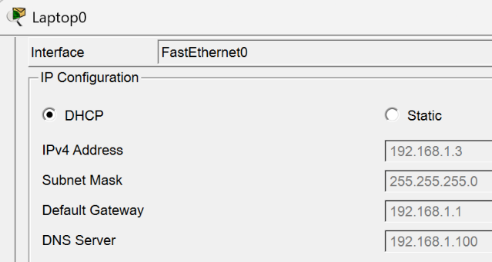
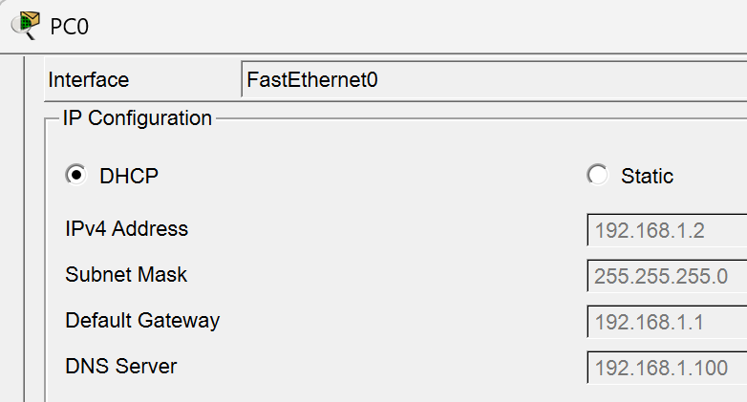
- Add a server to Switch0 (LAN1) and manually configure its IP address as previously assigned in the DHCP configuration.

IP Addressing Scheme
Device | Interface | IP Address | Subnet Mask | Connected To | Network
Prasoon_R0 | G0/0 | 172.16.1.1 | 255.255.255.252 | Prasoon_R1 | 172.16.1.0/30
Prasoon_R1 | G0/0 | 172.16.1.2 | 255.255.255.252 | Prasoon_R0
Prasoon_R0 | G0/1 | 192.168.1.1 | 255.255.255.0 | Switch0 (LAN1) | 192.168.1.0/24
Prasoon_R1 | G0/1 | 192.168.2.1 | 255.255.255.0 | Switch1 (LAN2) | 192.168.2.0/24

DNS Server Configuration
Steps:
- Click on the Server0.
- Select Services.
- Click DNS.
- Turn DNS Service ON.
- Add DNS Records.
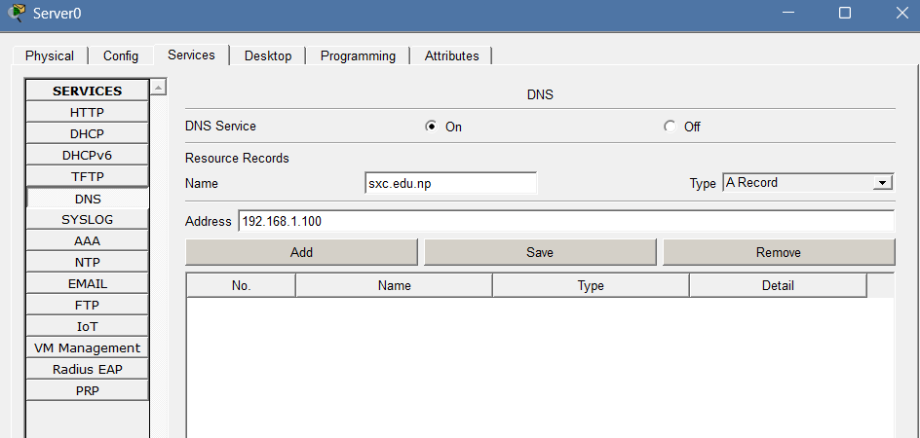
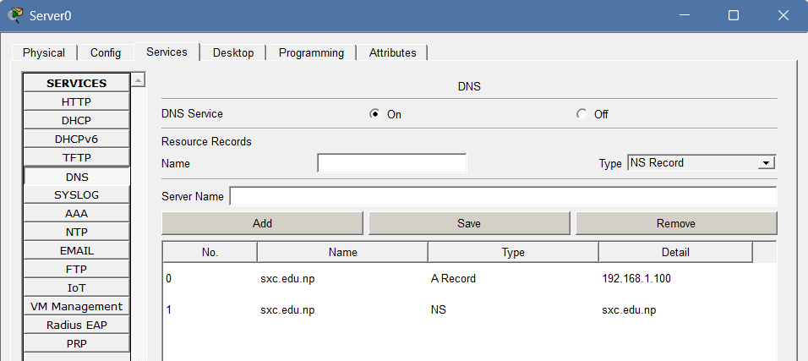
- Web Server and Client Configuration
Steps:
- Click on the Server0.
- Select Services.
- Click HTTP.
- Turn HTTP ON.
- Edit index.html.
- Save.
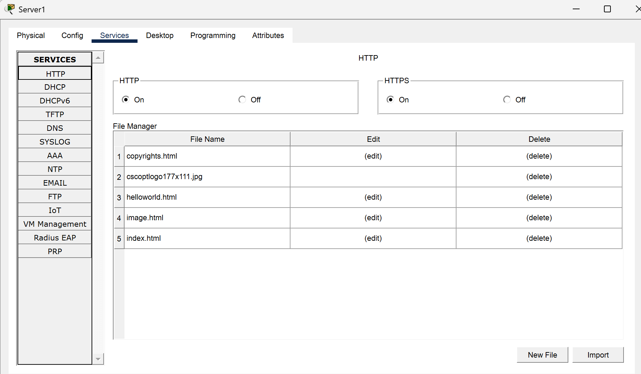
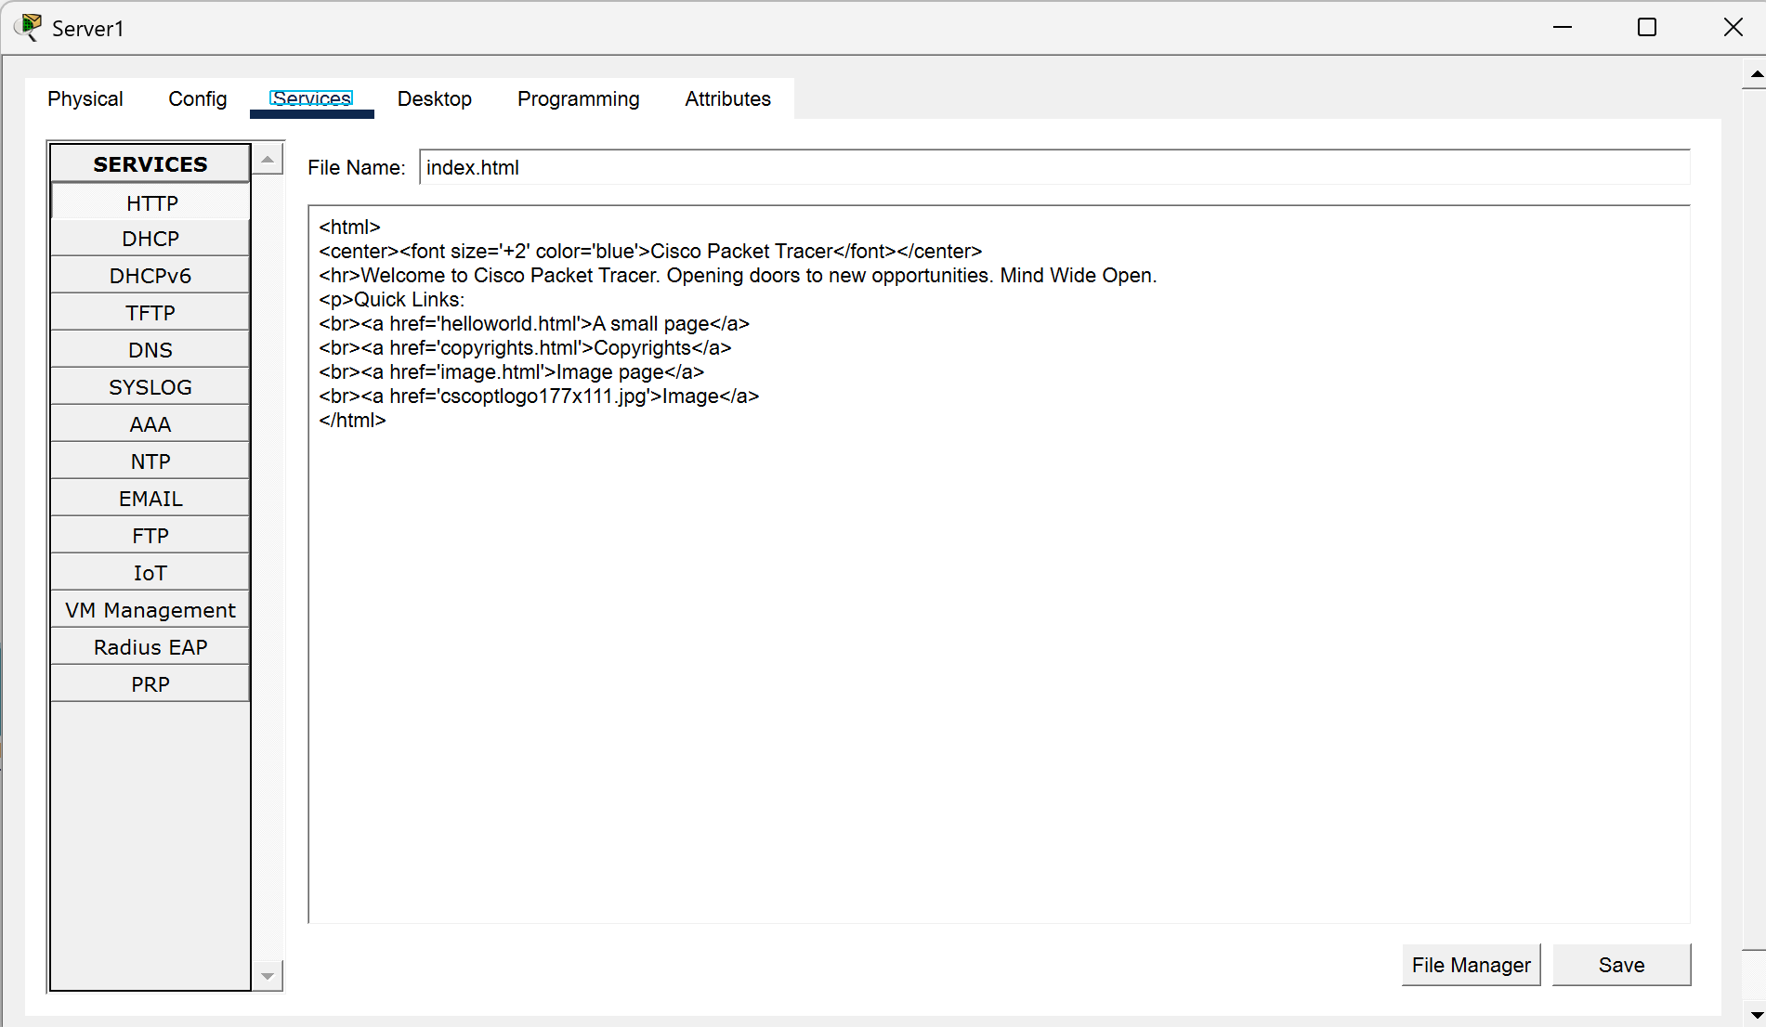
- To check this web server, go to any end device of LAN2 and click on Desktop.
- Then go to Web Browser.
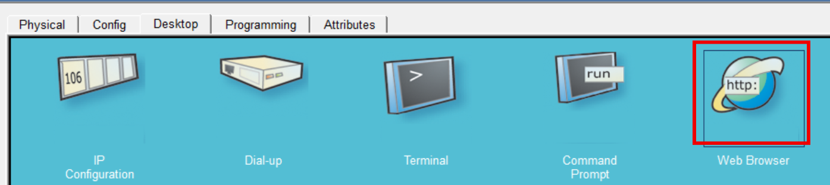
- Look up the domain name we saved ‘sxc.edu.np’.
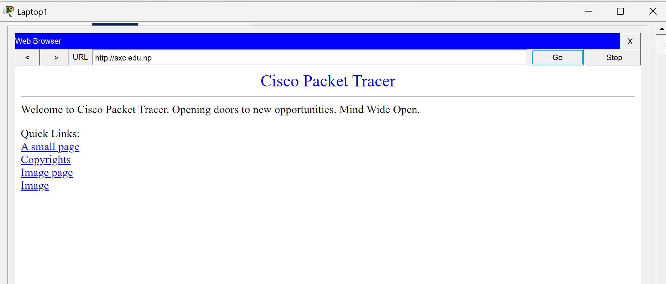

- Email Server and Client Configuration
Steps
- Click on the Server0.
- Select Services.
- Click EMAIL.
- Turn SMTP ON.
- Turn POP3 ON.
- Create Domain.
- Create Users.
- Save.
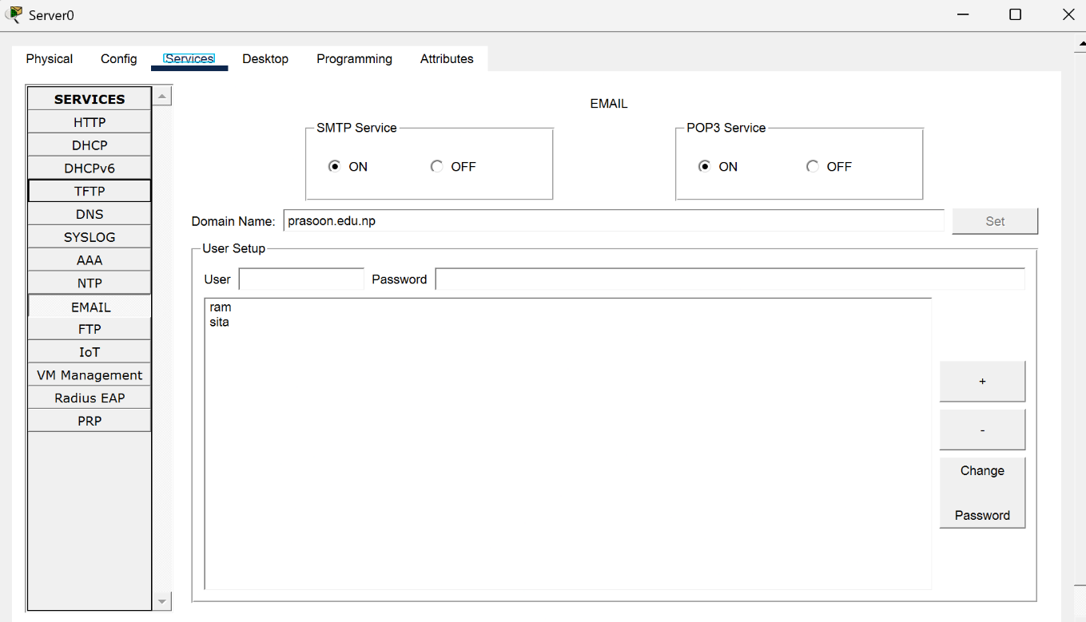
- Login the established user accounts on any end devices to use the email services.
- To login, click on the end device, then on Desktop click on the Email icon.
- Click on Configure Mail.
- Then enter the respective information as shown below and click Save.
- Repeat these on all the end devices with the users’ information labeled in each device.

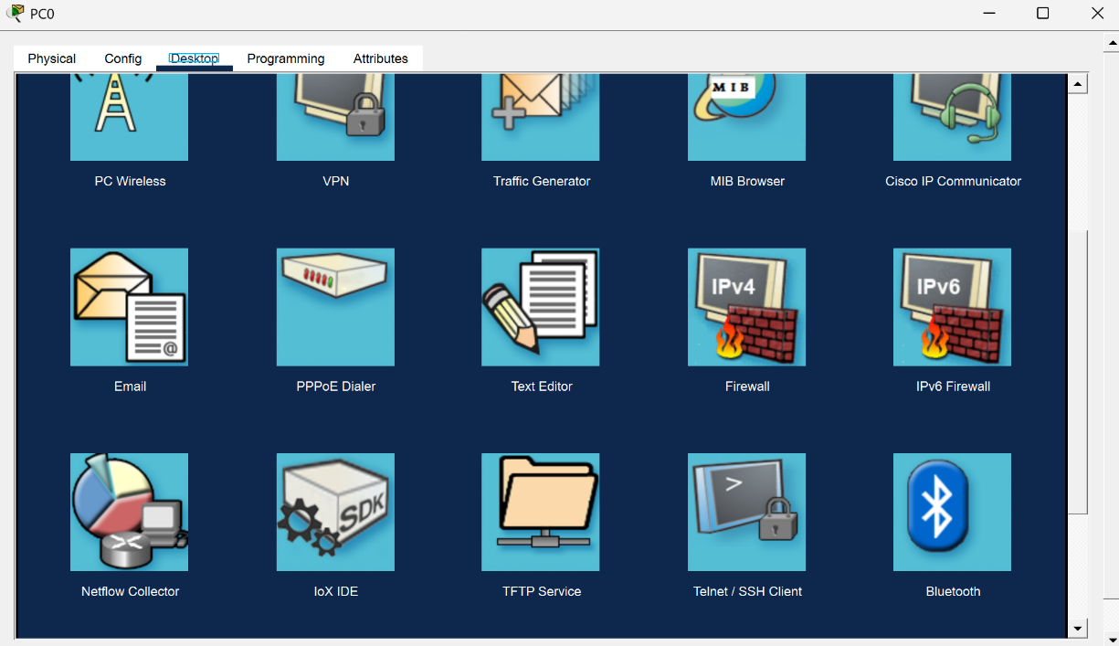
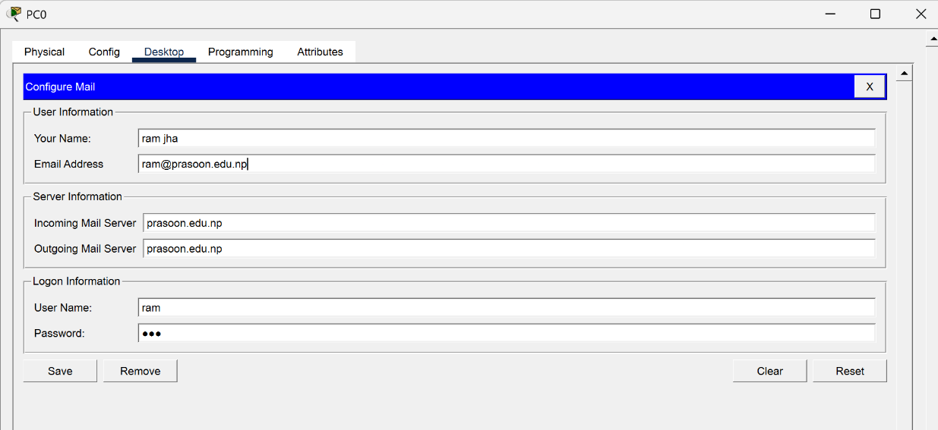
- Sending Email:
- Then go for Compose.
- Fill in the “To:” with any valid email address that we have configured previously.
- Write down the necessary subject and message.
- Click Send.
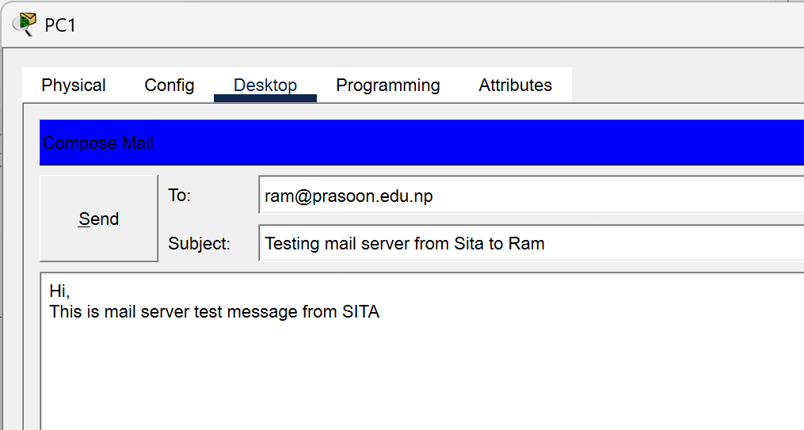

- Receiving Email:
- Go for Receive.
- Verify that the previously sent email has been successfully received by the respective device.

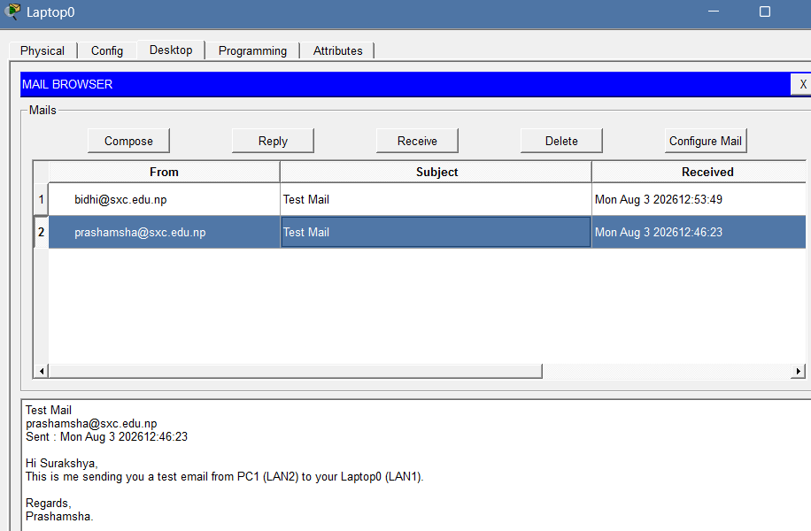

- Replying to an Email:
- Click on reply
- Write a reply email and click send
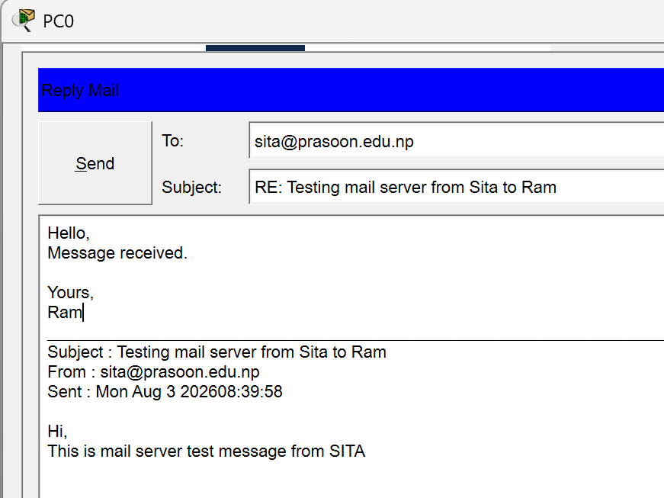

Observation
DNS, Web Server, and Email Server services were successfully configured in Cisco Packet Tracer. DNS records allowed clients to resolve the configured domain name sxc.edu.np to the server's IP address. The web server successfully hosted and displayed the configured web page when accessed from a client device. The email server was configured with SMTP and POP3 services, allowing users to send, receive, and reply to emails successfully. DHCP and RIP Version 2 also enabled automatic IP configuration and communication between the different LANs.

Conclusion
The DNS, Web Server, and Email Server were successfully configured and tested in Cisco Packet Tracer. DNS provided domain name resolution, the web server delivered web content to clients, and the email server enabled communication through sending, receiving, and replying to emails. Successful testing confirmed proper connectivity and operation of the configured network services.

